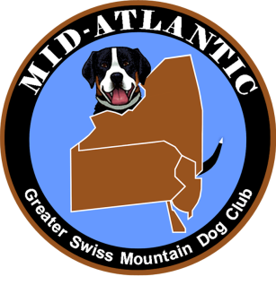
Mid Atlantic Greater Swiss Mountain Dog Club
Annual Picnic and Meeting
October 5, 2019
Tonia Adam’s
4840 Lisa Drive
Schnecksville, PA

President Hecker called the meeting to order at 3:00

Attendance: All those in attendance signed the attendance sheet.

Approval of Minutes: A motion to approve the minutes from last year’s Picnic/Meeting held on September 8, 2018 Laurie Grace. Seconded by Gene Grace
Approved

Reports of Officers:
President: Janie Hecker-none
Vice President: Denise Mitterando-no report
Secretary: Andrea Haubrick-no report
Treasurer-Stephanie Dooley-Stephanie gave an explanation of the breakdown of the budget. She explained each committee or Account and gave the membership the total allotted for the year and how it was to be used. Motion by Treasurer Stephanie Dooley was made to approve the budget.
Approved

Reports from Committees:
Education Committee –Carol Gehret reported that Bark Around the Park will be held May 17, 202 at the Macungie Memorial Park. All About Dogs will be held June 202 in Sinking Springs, PA.
The new event called Fast Cat will be part of these events and Sarah Winklevoss explained how it was run.

Regional Activities-Denise Mitterando
The Winery set for October 26, 2019 in Robbinsville, NJ
Paws on the Parkway December 3, 2019 Allentown, PA
Jack Frost Parade November 3, 2019 in Robesonia, PA
C and P even in Louisa, VA November 9, 10, 11, 2019

Specialty Show Committee-Joe Neuman
MAGS Specialty will be held at he Allentown Fairgrounds Agri-Plex on December 14, 2019.

Nominating Committee- Sharon Gardner
The Officers nominated and accepted for the 2020 year are as follows:
President-Janie Hecker
Vice President-Denise Mitterando
Secretary- Tara Lloyd
Treasurer-Stephanie Dooley

Board Members:
Joe Neuman
Jim Hauptly
Wayne Hecker
Carol Gehret
Sharon Gardner
Tonia Adams
Sarah Winklevoss

Working Events Committee-Sharon Gardner and Denise Mitterando
A pack hike is scheduled for the last weekend in March 2020 with more information to follow.
Weight Pulls, CGC and Trick Dog title testing opportunities, Drafting Clinic and Practice session.

Old Business:
Board voted to purchase Rally signs.
Board voted to support the purchase of the MAGS artwork that can be used for future sales of shirts and sale items.

New Business-

Joe Neuman would like to assess the interest in a seminar on Greater Swiss Mountain Dog structure. He would be using the Puppy Puzzle material by Pat Hastings and Adult Dog Standards set forth by the AKC. This would be offered at no charge. This is to encourage not only dogs in Confirmation, but new puppy owners to help them evaluate the dogs they are choosing. He would like members to respond if interested and suggest a place to hold the seminars.

A motion to adjourn was by Sharon Gardner. Seconded by Gene Grace.

Approved

