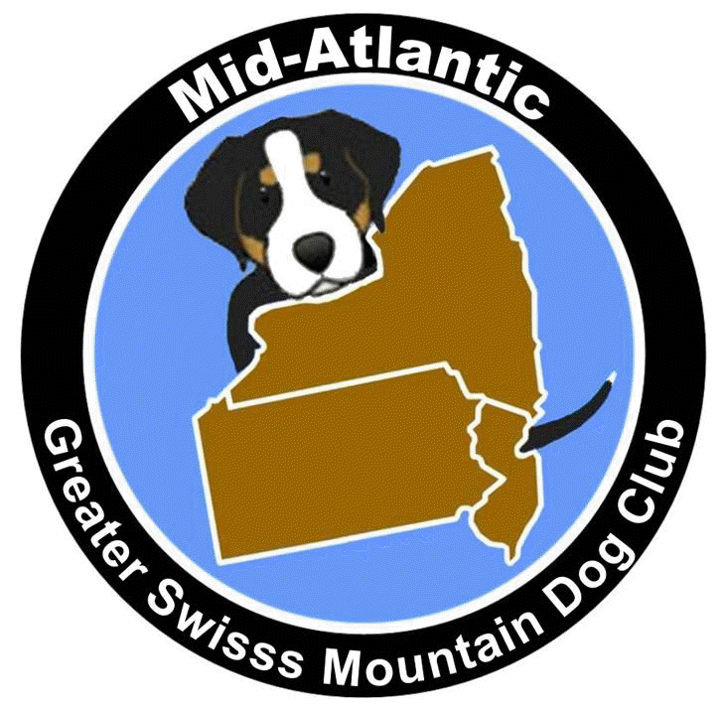
Mid Atlantic Greater Swiss Mountain Dog Club
Markley Residence
120 Ridgeview Road North
Elizabethtown, Pa 17022
Saturday, August 12, 2017
Minutes

Attendance: Joe Neuman, Carol Neuman, Jim Hauptly, Carol Gehret via telephone, Wayne Hecker, Janie Hecker, Katie Markley

Having received Doreen Holly’s resignation as President and in the absence of Vice-President Chris Gisewhite, Joe Neuman, Past President acted as President.
No Secretary report was given
No treasurer’s report was given
Wayne Hecker made a motion to accept the By-laws. Seconded by Katie Markley.
During discussion, Jim Hauptly raised an objection to the idea that actual vote counts would not be available to the membership. Janie Hecker supported his position.
Jim Hauptly made a motion to amend the by-laws to include the words “We will notify the membership of the actual count of votes for contested positions”. Seconded by Katie Markley. Approved
Wayne Hecker made the motion to accept the by-laws as amended. Seconded by Jim Hauptly. Approved

Joe Neuman discussed moving the MAGS Specialty 2018 to Harrisburg in conjunction with the Penn Ridge Kennel Club point show in August. In addition to conformation, obedience and rally, we may be able to offer weight pulling and or carting to entice more Swissie owners to attend not only the Specialty but the annual MAGS meeting/picnic.

Committees
Officers and Board members should not chair committees but mentor the chairs of committees. We need to get more members to become “hands on” active in MAGS.
The president should make a list of committees that are essential for the running of all aspects of the club.
There is still confusion about the geographical boundaries of our club due to the information on the GSMDCA (National) Club website. Is Delaware part of MAGS or C&P?
We need to have this clarified.

Joe made a motion to adjourn. Wayne Hecker Seconded

